Original

<https://www.lucidchart.com/documents/edit/d35dc07c-d0a3-4c74-95eb-6092c9210bab>

Different one based off:

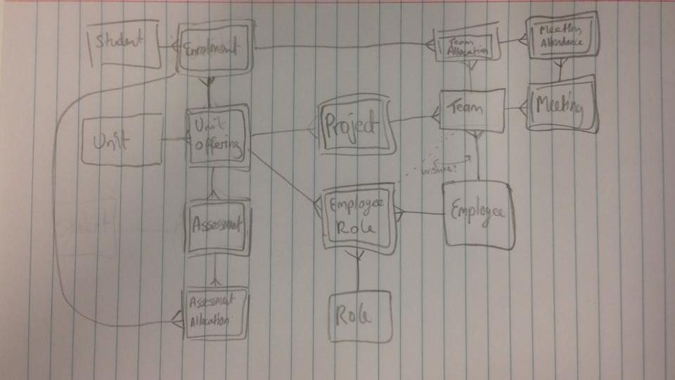

<https://www.lucidchart.com/invitations/accept/42abdfd2-8464-4d5b-a58f-5f8550415fd5>

SQL for this ^^ is “DDL.txt”